Octavio Montestruque Bisso

Martín Fabbri García

Ángeles Maqueira Yamasaki

Katerine Tapia Vila

University of Lima, Lima-Perú

**Velarde Bergman, Héctor (May, 14, 1898 – December, 22, 1989)**

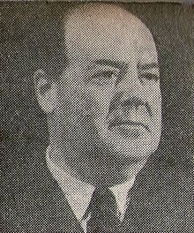

<http://es.wikipedia.org/wiki/Héctor_Velarde_Bergmann>

Hector Velarde was an architect born in Lima Peru May 14, 1898. Due to the diplomatic functions of his father, Velarde´s childhood and adolescence was spent between Brazil, Switzerland and Paris. Velarde studied in France at the *Ecole Speciale des Travaux Publics de L'Industrie du Batiment*, graduating as an architect-engineer in 1919. In 1920, he entered the *Ecole des Beaux Arts* where he studied at the atelier of Victor Laloux, a clear trend neoclassical french architect. In 1924 Hector Velarde comes to Lima, and from that year until 1927 is dedicated to the diplomatic service, to literature and journalism. At 1928, he resigned to the diplomatic corps and devotes full time to the practice of architecture, construction and teaching in various institutions of higher education, becoming Vice Chancellor of the University of Lima. In his career as an architect, he built several projects that can be seen in the city until today, as well as a variety of academic texts and humorous stories that complete their life. Velarde died on December 22, 1989.

The presence of Hector Velarde for twentieth-century peruvian architecture is critical because it stands as an architect of transition between the academic style and modern architecture. For this reason, you can find a variety of architectural languages ​​throughout his built work, one of the few peruvian architects who have been successful in achieving the transition of styles in the twentieth century. Despite its projecting career changes, you can determine a true modern spirit in his thinking by the many writings, which mentions the time of change that occurs in the city of Lima by the increase in new constructions in the skyline. In his academic writings and in the humorous ones, Velarde had a mature posture about modernity, where it promotes a series of changes and developments in the city, especially since the presence of new avenues and main streets in Lima, but also encourages the preservation and conservation of historical past that can be seen in the peruvian colonial architecture. However, the international presence of Velarde was as a modern architect and representative for the twentieth century peruvian architecture, being invited by Josep Lluís Sert to the International Congress of Modern Architecture CIAM held in the city of Bergamo.

Within the built work of Velarde, there are three groups of buildings that can be classified by its style and its location in the city, what makes us think of a vocation almost contextualist rather than dogmatic in the choice of his architectural language . While passing through the transition between academisismo and modernity, his built work reflects this change not in a chronological order but rather presents a variety of styles that can be seen related to their location and level of development of the city.

In one group, we can distinguish his works in the consolidated city, in the historic center of Lima, Pueblo Libre, Jesus Maria and Rimac. Here you see a conservative style that aligns more with the academic, seeking a dialogue with the architecture that existed in those sectors of the city. In a second stage, you can see that it risks a little more with the modern style in the city that is in developing, like the districts of San Isidro, Miraflores, or Magdalena. Here we find buildings that, are not a technologycal development in line with modern standards, but rather with traditional construction based on local labor -is important to mention that in Peru the development of the construction industry was very slow, which gave an almost artisan way of building- manage aside the use of ornament in their facades and seeking purity of form and continuity of space. At this stage, we can also see buildings that are typical of modernity as would be the schools, universities, museums and hospitals, which would become to the present, in buildings representative to the peruvian capital.

Finally, we can find a last step that occurs in the outskirts of the city, especially in Lima as Ancon, where you can see a full modernity in Hector Velarde´s architecture, also contributing to the “buque” style, very representative of the peruvian coastal architecture. The “buque” style is a way of adapting to modernity and proper language typical of our culture, where the purity of the volumes seeks to imitate heavy and forceful forms of ships, constantly seen in peruvian ports. The “buque” style means a local variant of Art Deco building more efficient in constructive terms than the difficulties involved in the neo-colonial and neo-Inca styles. In Peru the “buque” style is used in workers' housing and some recreational and leisure buildings typical of modernity (cinemas, stadiums). Perhaps this preference for linear sober language and “buque” style comes from the aesthetic influence in the modern forms of the machines of the time.

The latter group also highlighted buildings devoted to leisure and dispersion of Lima's upper class, where the spaces are repeated and terraced oceanfront, continuous interiors that are linked to the outside, highlighting the enjoyment and relaxation activities of users . Buildings of this group can be identified as significant like Casino Ancon, the Baths of Miraflores or Club Regatas Union of La Punta. Perhaps, those are the most significant buildings in Hector Velrde´s modern architecture.

**Lista de trabajos**

1925 House Ramos Cabieses (Calle Belén, Lima).

1928 Office building at Azángaro Street (Lima).

1928-1929 Adaptation of Casa de Piedra to Club de la Unión (Interior).

1929 Mr. Alejandro de la Puente´s House (Av. Arenales, Lima).

1930 Mr. Haaker´s House (San Isidro).

1930-1935 Mr. A. Leguía´s House (Initiated by architect Clause Sahut).

Mrs. Carmen García´s House (Santa Beatriz, Lima).

Mr. Luis Aubry´s House (Lima).

1932 Rotary Club´s minimal house (With architect Alfredo Dammert).

1934 Mr. Carlos Graña´s House (Av. Brasil).

Office building Compañía de Seguros La Nacional (Lima).

Mr. Thodore Nichtawitz´s House (Miraflores, Lima).

Miraflores baths (Lima).

1935 Aubry´s family house (Lince, Lima).

Group of houses in Miraflores (Av. Grau con av. Gonzales).

Car show gallery Peruvian Autos (Av. Wilson, Lima).

Miss Echocopar´s House (Av. Pardo, Lima).

1935-1936 Club de Regatas Lima (Chorrillos, Lima).

Ulloa´s House (La Punta).

1935-1940 Reshuffle of Backus & Jhonston office building (Rímac, Lima)

Museum of Anthopology (Pueblo Libre, Lima)

Mr. Rothmann´House (Armendáriz Park, Lima)

1937 Santo Toribio´s seminar (Av. La Marina con Av. Sucre)

Club del Círculo Militar (Plaza San Martin, Lima)

Wiese Montero´s House (Chosica, Lima)

Office building of Compañía de Seguros Sud América (Plaza San Martin, Lima)

Velarde Ortiz de Zevallos´House (Lima)

1938 Miro Quesada Sosa´s House (San Isidro, Lima)

Raúl E. Porturas´House (Calle Shell, Lima)

1939 Santa Úrsula School (With architect Paul Linder)

1940 Mr. Lizardo Alzamora´s House (Jr. Puno)

Mr. Carlos Nicolini´s House (San Isidro, Lima)

Brasil building (With architect Paul Linder)

Mr. Enrique Gonzales Orbegoso´s House (Av. Arequipa, Lima)

Mr. Jorge Basadre´s House (San Isidro, Lima)

Offices of the Ministry of Foreign Affairs (Campo de Marte, Lima)

1940-1948 San Agustín of Arequipa National University (Parcially built)

1941 Oaths living Courthouse (Paseo de la Republica, Lima)

1940-1942 Nunciatura Apostólica (Av. Salaverry, Lima)

1941-1942 Reiser & Curioni building (Lima)

1941-1946 Ancón Center (Lima)

1942 Mossone Hotel in Ica (With architect Roberto Haaker)

Bifamiliar building in Quilca (Lima)

1942-1946 Casino of Ancón

1943 Club Regatas Unión (La Punta, Lima)

1940 Gibson´s House (Av. Javier Prado)

1940-1945 Matellini housing (Av. Arequipa, Lima)

Restoration of the headquarters of the Thirth Orden of San Francisco (Lima)

1944 Restoration of the San Pedro church (Jr. Azángaro, Lima)

Restoration of the Acho square (con Luis Ortiz de Zevallos y otros)

1945 Monterrey building (Lima)

Mr. Benito Lores´country house (Ancón, Lima)

Three houses for the Continental Bank (Av. Javier Prado, Lima)

Ramos Cabieses House (Magdalena)

1945-1950 Mr. Andrés Alvarez Calderón´s House (San Isidro, Lima)

Three floor house (Centro de Lima, Lima)

1947 Building for the Ignacio R. de Canevaro Foundation (Jr. Lampa)

Apartment building in Ancón (Lima)

1948 Santo Toribio´s seminar church (Lima)

El Parque building (Av. Armendáriz con Parque Salazar)

1949 La Playa building (Malecón San Martin, Ancón, Lima)

International pavilion for the Petrolium Co.

San Isidro Clinic (Lima)

1950 Multifamily building (Miraflores, Lima)

Comercial building Bata Rímac (Av. Larco, Lima)

Nuestra Señora de Lurdes School (Piura)

Restoration of the Convent of the Patrocinio nuns (Lima)

1943-1950 Bravo Chico tuberculosis hospital(Lima)

1950-1955 Apartment store building (La Victoria, Lima)

1952 Library of the National Institute of males (La Cantuta, Lima)

1953 Continental Bank Headquarters (Lima)

1954 Maury Hotel (Lima)

1955-1958 Tacna´s public library (Tacna)

Granda´s House (San Isidro)

1959-1960 El Olivar theatre (San Isidro, Lima)

Restoration of the Segura Theatre (Lima

Bullfighting Museum restoration (Lima)

1961 Restoration of the Nazarenas Convent and Church (Lima)

Convent and services building for Belén School (San Isidro, Lima)

1963 Restoration of the Casa de Pilatos (Lima)

1966 Classrooms at the University of Lima (Lima)

Alianza Francesa building (Lima)

1970 Hunt Family House (La Molina, Lima)

1971 Restoration of the Casa Negreiros (Lima)

**References**

Gutiérrez, R. (2002). Héctor Velarde. Lima: Epígrafe.

Gutiérrez, R. (1998). Arquitectura latinoamericana en el siglo XX. Madrid: Lundwerg Editores.

Ludeña, W. (1997). Ideas y arquitectura en el Perú del siglo XX. Lima: SEMSA.

**Visual material:**

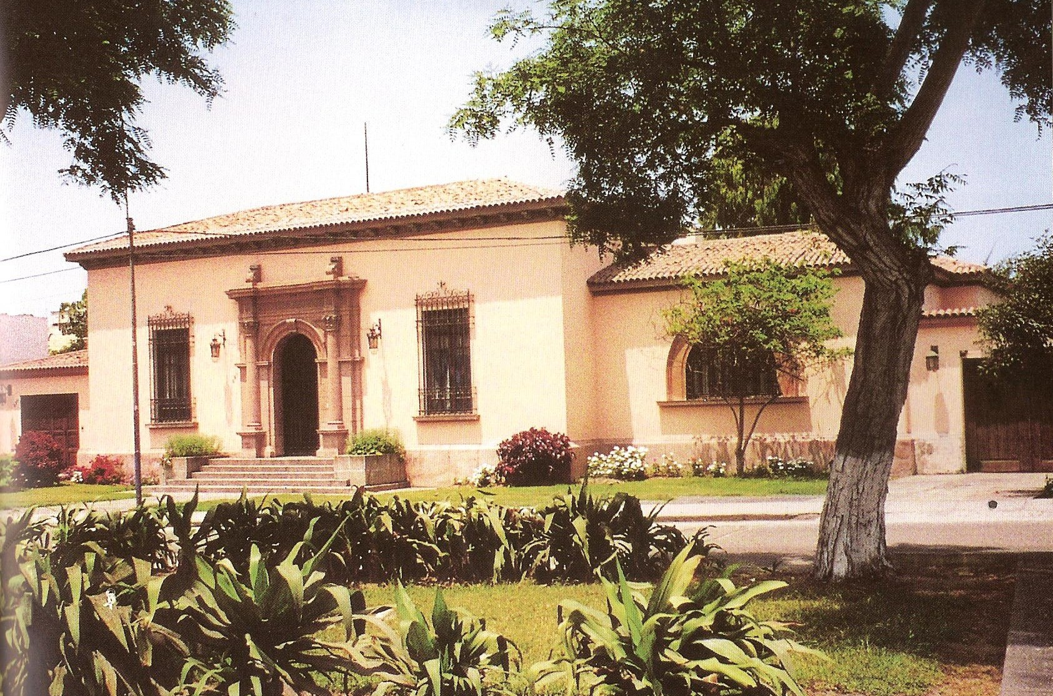

Ramos Cabieses House, 1925.

Copyright: Gutiérrez, R. (2002). Héctor Velarde. Lima: Epígrafe.

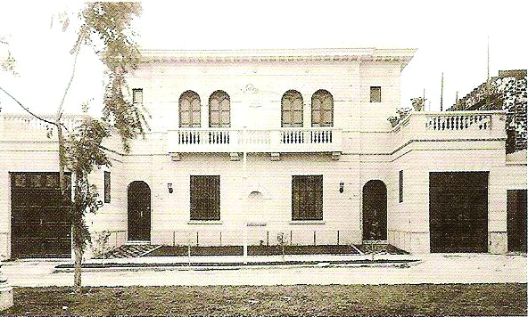

Mr. Haaker´s House, 1930.

Copyright: Gutiérrez, R. (2002). Héctor Velarde. Lima: Epígrafe.

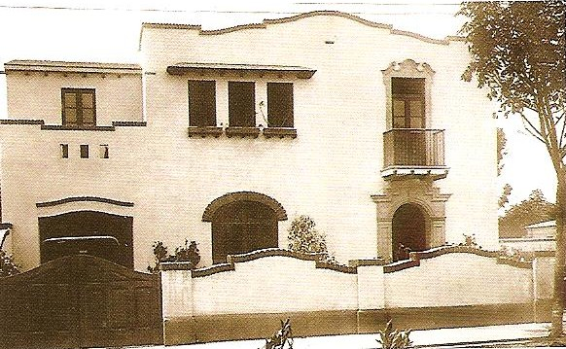

Aubury House, 1935.

Copyright: Gutiérrez, R. (2002). Héctor Velarde. Lima: Epígrafe.

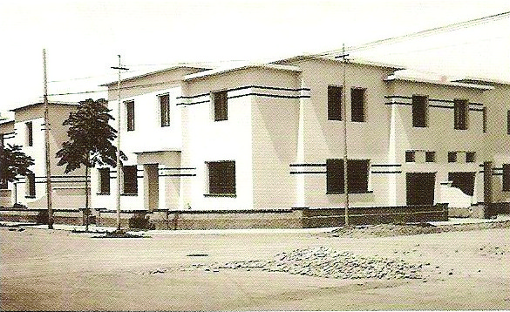

Group of houses in Miraflores, 1935.

Copyright: Gutiérrez, R. (2002). Héctor Velarde. Lima: Epígrafe.

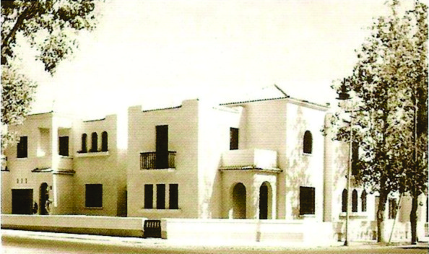

Miss Echecopar´s House, 1935.

Copyright: Gutiérrez, R. (2002). Héctor Velarde. Lima: Epígrafe.

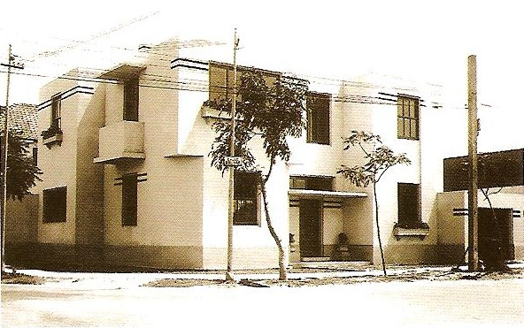

Mr. Thodore Nichtawitz´s House, 1934

Copyright: Gutiérrez, R. (2002). Héctor Velarde. Lima: Epígrafe.

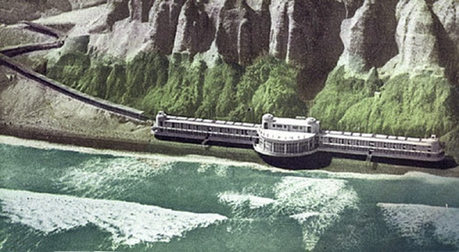

The Miraflores baths, 1934-1935

Copyright: La Forma Moderna en Latinoamérica, <http://laformamodernaenlatinoamerica.blogspot.com/2013/07/banos-de-miraflores.html>

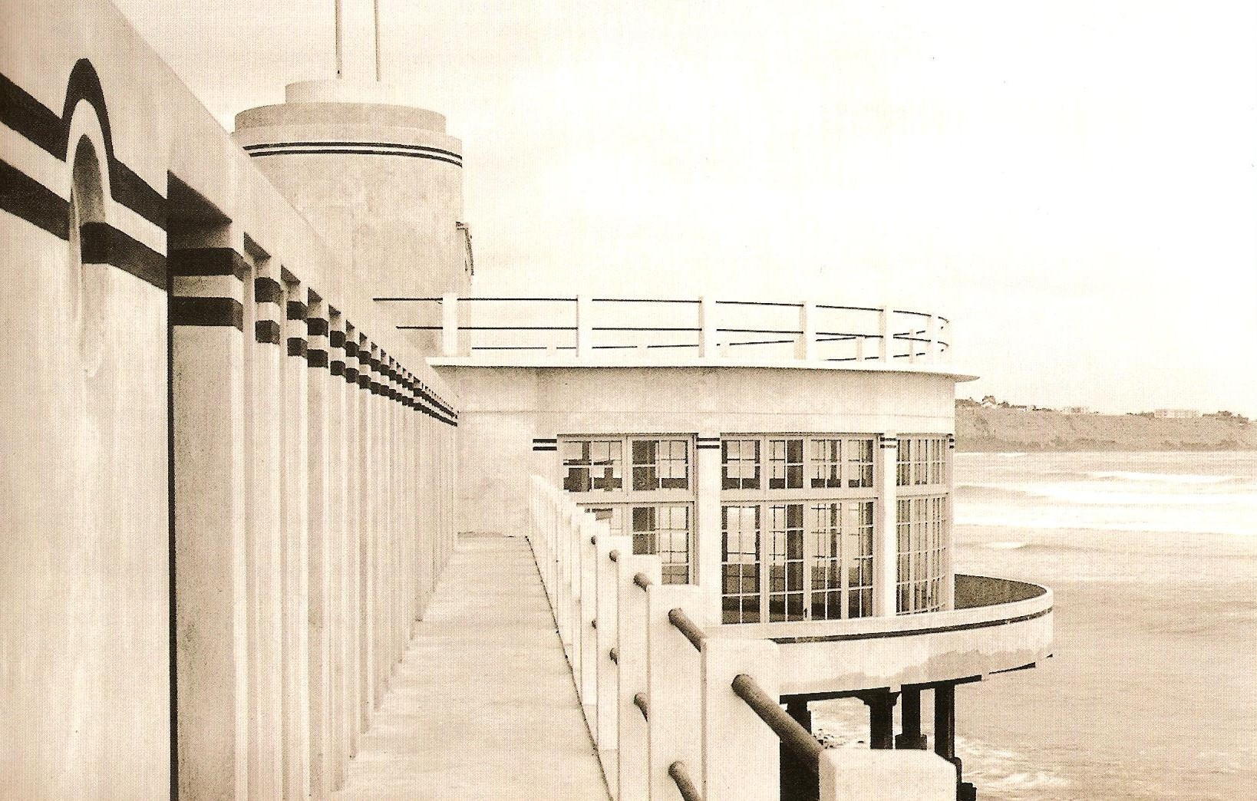

The Miraflores baths, 1934-1935

Copyright: Gutiérrez, R. (2002). Héctor Velarde. Lima: Epígrafe.

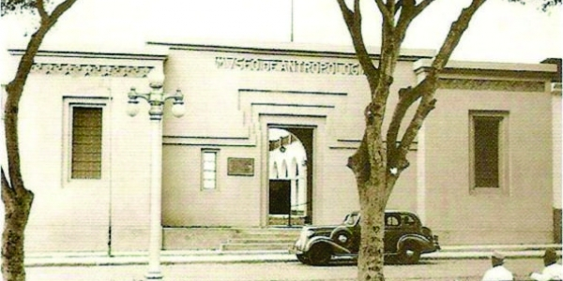

Museum of Anthropology.1935-1940

Copyright: Universidad de Lima, <http://www.ulima.edu.pe/pregrado/arquitectura-y-gestion-de-proyectos/noticias/homenaje-hector-velarde>

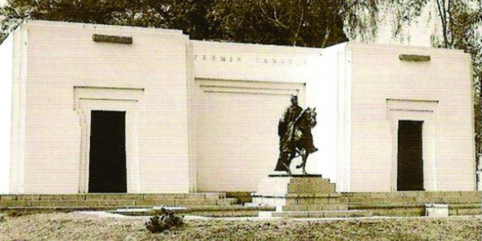

Fermín Tangüis Monument, 1939

Copyright: Universidad de Lima, <http://www.ulima.edu.pe/pregrado/arquitectura-y-gestion-de-proyectos/noticias/homenaje-hector-velarde>

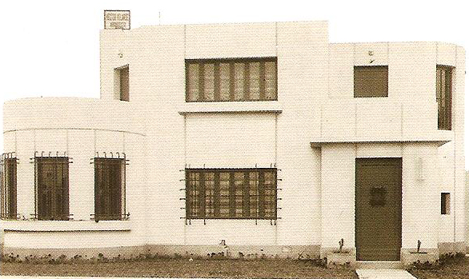

Lores House, 1940

Copyright: Gutiérrez, R. (2002). Héctor Velarde. Lima: Epígrafe.

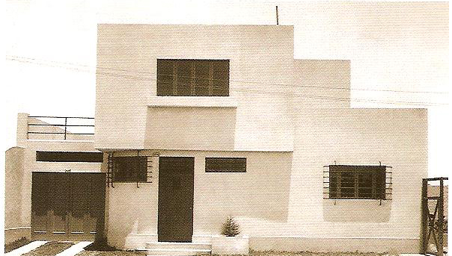

Mr. Luis Graña´s House, 1940

Copyright: Gutiérrez, R. (2002). Héctor Velarde. Lima: Epígrafe.

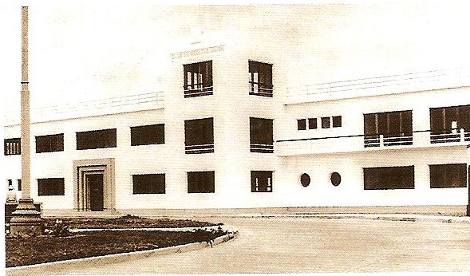

Club Regatas Union, 1943

Copyright: Gutiérrez, R. (2002). Héctor Velarde. Lima: Epígrafe.

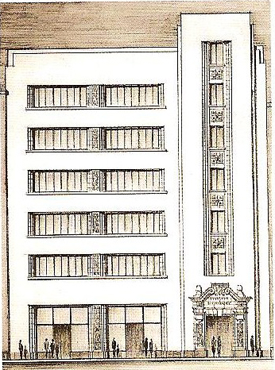

Monterrey building, 1945

Copyright: Gutiérrez, R. (2002). Héctor Velarde. Lima: Epígrafe.

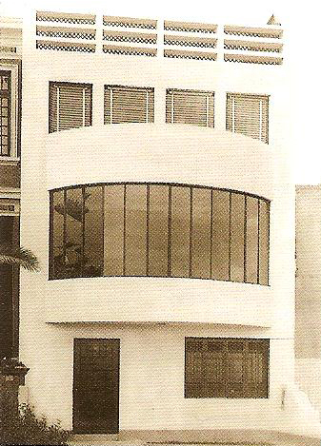

Three floor house, 1945-1950

Copyright: Gutiérrez, R. (2002). Héctor Velarde. Lima: Epígrafe.

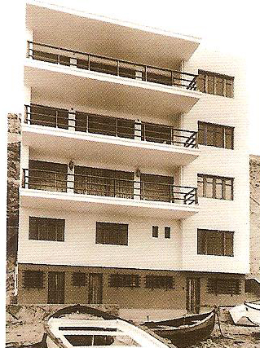

La Playa building, 1949

Copyright: Gutiérrez, R. (2002). Héctor Velarde. Lima: Epígrafe.

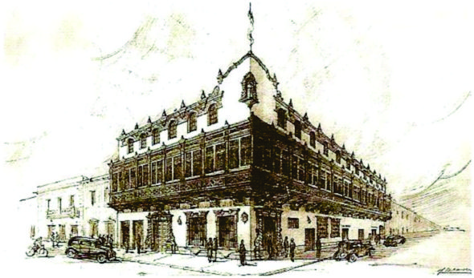

Maury Hotel, 1954.

Copyright: Gutiérrez, R. (2002). Héctor Velarde. Lima: Epígrafe.

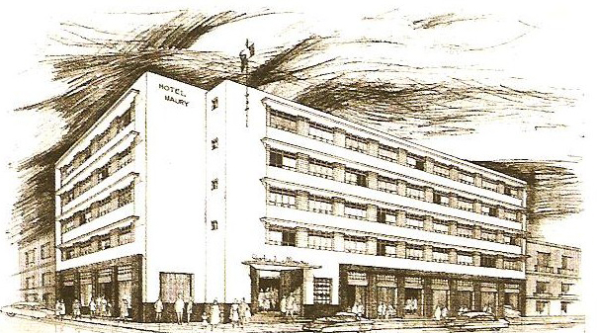

Maury Hotel (second proposal), 1954

Copyright: Gutiérrez, R. (2002). Héctor Velarde. Lima: Epígrafe.

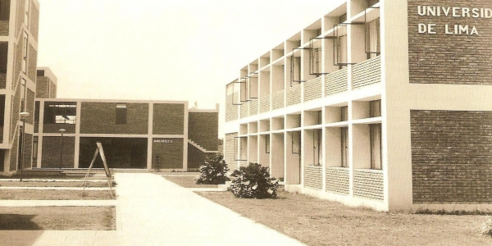

University of Lima, 1966

Copyright: Universidad de Lima, <http://www.ulima.edu.pe/pregrado/arquitectura-y-gestion-de-proyectos/noticias/homenaje-hector-velarde>